**Project 02_05_01**

In this Project we will build a series of PHP applications to test our knowledge of the unit. Be sure to document all of your code to indicate your understanding.

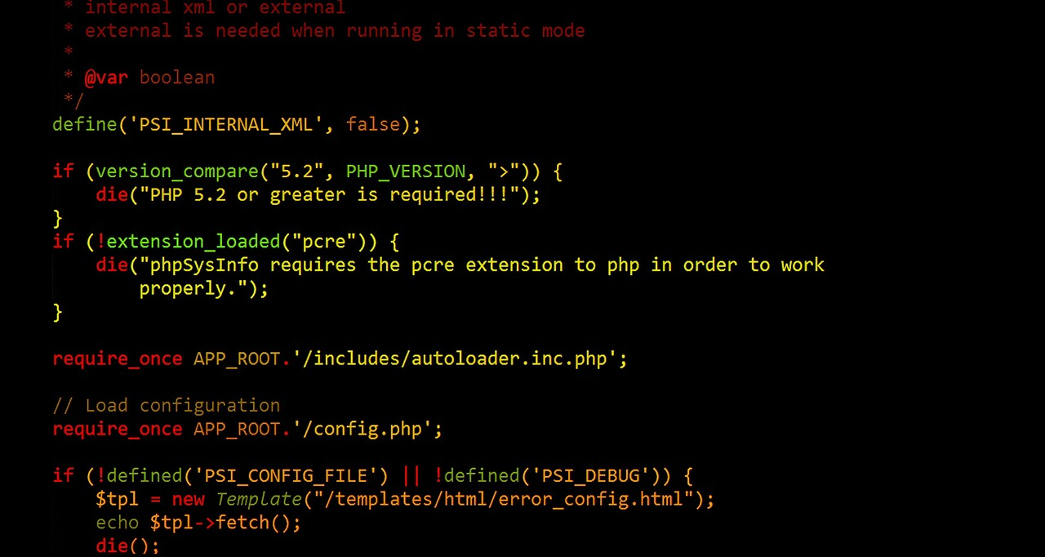   
**Part 01**

This application may be done as an All-in-One form or a form that calls to another display form with links back and forth.

Create an application with a form that registers video game players for a video game. The form should be called ***TheGame.php***. Use a single text file for storage for the gamers that will be named ***TheGamers.txt***.

Information for each gamer should be saved in a single delimited text string. Each individual gamer record should be on a separate line. Include the required fields for the gamer’s username, password in md5 format, full name, email, age, screen name, and comments.

Do a professional display of the registered gamers, a nicely formatted and labeled list or table of all of the gamers, with a separator, should be displayed below the form.